Part 1

- The following question is about magnets.
- Iron is a magnetic material.
Name two other magnetic elements. (2)
- Cobalt (1)
- Nickel (1)

- Describe the effect a permanent magnet will have on an induced magnet. (1)
- A permanent magnet will only attract an induced magnet. (1)

- Describe how a piece of iron can be made an induced magnet. (1)
- Placing the piece of iron in a magnetic field will make the piece of iron an induced magnet. (1)

- Describe how an induced magnet can be demagnetised. (1)
- Removing the piece of iron from the magnetic field will remove all/most of the magnetism. (1)

- A student is asked to find the magnetic field pattern of a permanent bar magnet.
Describe two methods the student could use to find the magnetic field pattern of the permanent bar magnet. You may draw a diagram to help answer this question. (4)
- Use iron filings  - Place a bar magnet under a sheet of paper  - Sprinkle iron filings on top of the paper  - Tap the paper  - The pattern the iron filings make is the shape of the magnetic field  Any 2 valid points (2) | - Use plotting compasses  - Place the plotting compasses around the bar magnet  - The direction the compass points is the direction of the magnetic field at that point  - Use a pencil to mark the direction of the field and use the compass to trace the field around the bar magnet.  Any 2 valid points (2)
- Explain how the student can determine where the magnetic field is strongest from the magnetic field pattern. (2)

- The field is strongest where there are the most magnetic field lines (1)
- So, strongest at the poles of the magnet (1)

- The Maglev train floats over its track using an electromagnet. Maglev trains have managed speeds in excess of 370 mph. A model of the Maglev train uses two permanent magnets to get the model to float over the track.
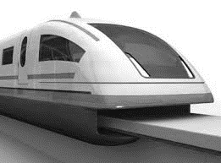
- Describe how the magnets must be arranged to get the model Maglev Train to float. (2)

- The magnets on the train and the magnets on the track must have the same pole facing each other (1)
- As like poles repel (1)

- Suggest an advantage of using the Maglev train compared to conventional trains. (1)
Reduced friction will mean that the Maglev train can travel faster as there will be a greater overall driving force (1)

Part 2
- Electric motors have many uses in the home.
- Give two uses of electric motors in the home. (2)
- Washing machines / tumble driers / food mixers / cd players / DVD players / games consoles / radio controlled toys 1 mark /valid point to a maximum of 2 marks

- Draw and label a diagram of a simple motor (4)
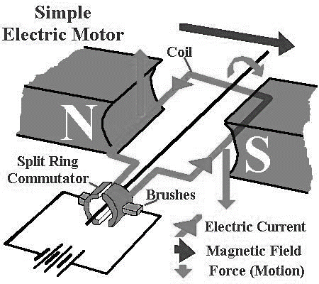
Diagram showing:
- Opposing N/S magnetic field (1)
- Coil of wire within this magnetic field (1)
- DC current being supplied to the coil (1)
- Some arrangement of a commutator/brushes
To reverse the current (1)

- State three changes that you could make to get the motor to spin faster. (3)

- Increase the current through the coils of wire (1)
- Use stronger magnets (1)
- Use more coils of wire (1)

- Give two changes that you could make to get the motor to reverse its direction of rotation. (2)

- Change the direction of current flow (1)
- Switch the polarity of the magnets (1)

- Figure 1 shows an electric bell. Electric bells are used in fire alarms.

- Explain how the electric bell works. (4)
Figure 1
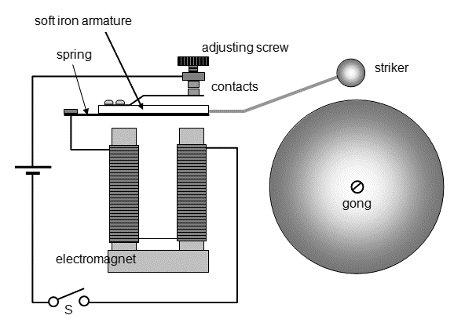
- When the switch is closed a current flows through the coil of wire
- This magnetises the iron core of the electromagnet
- The electromagnet attracts the soft iron armature
- Which makes the striker hit the bell
- This breaks the circuit
- Demagnetising the iron core and causing the spring to push the soft iron armature back up
- Which makes the circuit again, repeating the cycle.
1 mark / valid point up to a maximum of 4 marks

- Inside an electric bell there is a coil of wire called a solenoid.
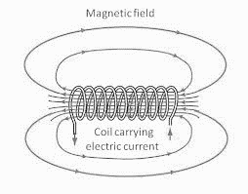
Draw the magnetic field pattern for a solenoid. (2)

Direction of lines of force (1)
Labelling of N and S (1)
S
N

- One method of making the magnetic field of the solenoid stronger is to increase the number of turns of wire on the solenoid.
Describe two other ways of making the magnetic field of the solenoid stronger. (2)
- Increase the current through the wire (1)
- Add a soft iron core between the coils (1)

- Electric bells are one use of electromagnets. Suggest two other uses of electromagnets. (2)
- In scrapyards to pick up cars
- In a loudspeaker
- In a microphone any two relevant uses (2)

- A straight wire carrying an electric current (I) is placed between two magnets, as shown in Figure
2. (HT)
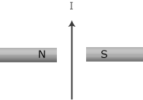
Figure 2

- The wire experiences a force. In which direction will the force act? Explain your answer. (2)
- Into the page (1)
- From Fleming's Left-Hand Rule (1)
- Explain why the wire will experience a force. (3)
- The magnetic field of the wire (1)
- Interacts with the magnetic field of the fixed magnets (1)
- Producing a force on the wire (and bar magnets) (1)

- The length of wire between the magnets if 4 cm and carries a current of 0.6 A. Work out the size of the force on the wire if the magnetic field strength is 0.05 T. (2)

force = magnetic flux density x current x length
- F = 0.05 x 0.6 x 0.04 (1)
- F = 0.0012 N (1)

- Figure 1 shows a generator. The generator is rotated by a handle and there is an alternating current output produced.
Figure 1

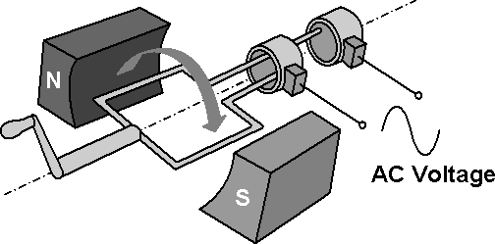

- Explain why the output of the generator, shown in Figure 1, is an alternating current. (5)
- As the coil of wire rotates
- The electrons inside the wire are made to move in one direction by the N-pole
- And then move in the opposite direction by the S-pole
- As the direction of movement of the coil has been reversed
- As the wires connecting the coil are in constant contact with each commutator
- The electrons in the external circuit keep changing direction
- Which is an alternating current. (any 5 valid points)

- As the coil of wire in the generator spins, an output potential difference is induced.
Explain how the size of this induced potential difference varies as the coil of wire spins. (4)
- Greatest potential difference induced when the magnetic field lines are being broken at the fastest rate (1)
- This occurs when the horizontal coil of wire is moving vertically through the magnetic field (1)
- No potential difference is induced when the coil moves parallel to the magnetic field lines (1)
- So, 0 V out at the top of the rotation. (1)

- Spinning the handle of the generator faster gives a greater induced potential difference.
Explain why rotating the handle faster gives a greater induced potential difference. (3)
- The faster the handle is spun the faster the coil moves in the magnetic field (1)
- Breaking the magnetic field lines at a greater rate (1)
- Inducing a greater potential difference. (1)
- Suggest one other way of getting a greater induced potential difference. Give a reason for you answer. (2)
- More coil of wire / Using stronger magnets
- More coils of wire will mean more wire breaking the field lines (1)
- Inducing a greater potential difference
- Using stronger magnets will mean that more magnetic field lines are in the same space, so the coils will break the field lines at a faster rate. (1)
- Figure 2 shows a cross section of a microphone.
A microphone can be used to record sound onto a hard drive.
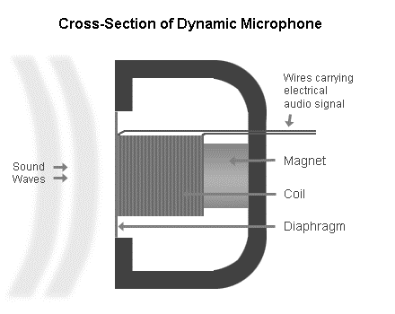
Figure 2

Explain how a microphone can be used to record sound onto a hard drive. (4)
- The sound waves make the diaphragm move (1)
- The diaphragm is connected to the coil, which moves over the magnet (1)
- Inducing a current by the generator effect (1)
- The electrical signals produced are then stored on the hard drive. (1)

- A step-down transformer is used in The National Grid to reduce the potential difference from 400,000 V to 15,000 V, before being further reduced to 230 V for use in the home.

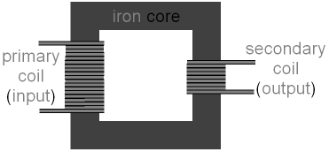
- Describe the construction of a step-down transformer. You may draw a labelled diagram to help you answer this question. (3)

- A step-down transformer can be used to charge laptop computers. A 230 V laptop computer charger has 600 turns of wire on the primary coil and 50 turns of wire on the secondary coil. Work out the output potential difference on the laptop charger. (3)
V_{p} / V_{s} = N_{p} / N_{s}
- 19.2 V (1)
- 12 times more turns of wire on Primary coil (1)
- So, Primary coil has a 12 times greater potential difference. (1)

- The current in the secondary coil of the laptop charger is 5A.
Work out the current in the primary coil of the laptop charger. (2)
V_{s} x I_{s} = V_{p} x I_{p}

- 0.42 A (1)
- Use of V_{s} x I_{s} = V_{p} x I_{p} (1)

- Explain why transformers are used in The National Grid. (4)
- Increasing the potential difference through the powerlines decreases the current (1)
- As the total power stays the same. (1)
- The greater the current the more the wires heat up (1)
- So a lower current means that the wires heat up less (1)
- Making transmission more efficient. (1)
1 mark / valid point up to a maximum of 4 marks

- Explain how a transformer works. You may draw a diagram to help answer this question.

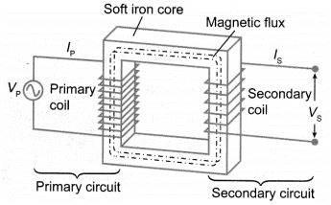

- An alternating current in the primary coil (1)
- Induces an alternating magnetic field in the laminated iron core. (1)
- As the alternating magnetic field is induced inside the secondary coil (1)
- A potential difference is induced in the secondary coil (1)
- By the generator effect (as the magnetic field is moving relative to the coil of wire) (1)

1 mark / valid point up to a maximum of 4 marks

